/\*Ashok IPBC - Mor Project R2SP6 Story 9 Lab 8.7.19\*/

Homework:

4. Complete R2:SP6: Story 9 – Create the Loans Overview part of the Dashboard. Explain the entire

process with explanations &amp; screenshots. While everything doesn’t need to be captured,

milestones such as completed queries and reports should be documented.

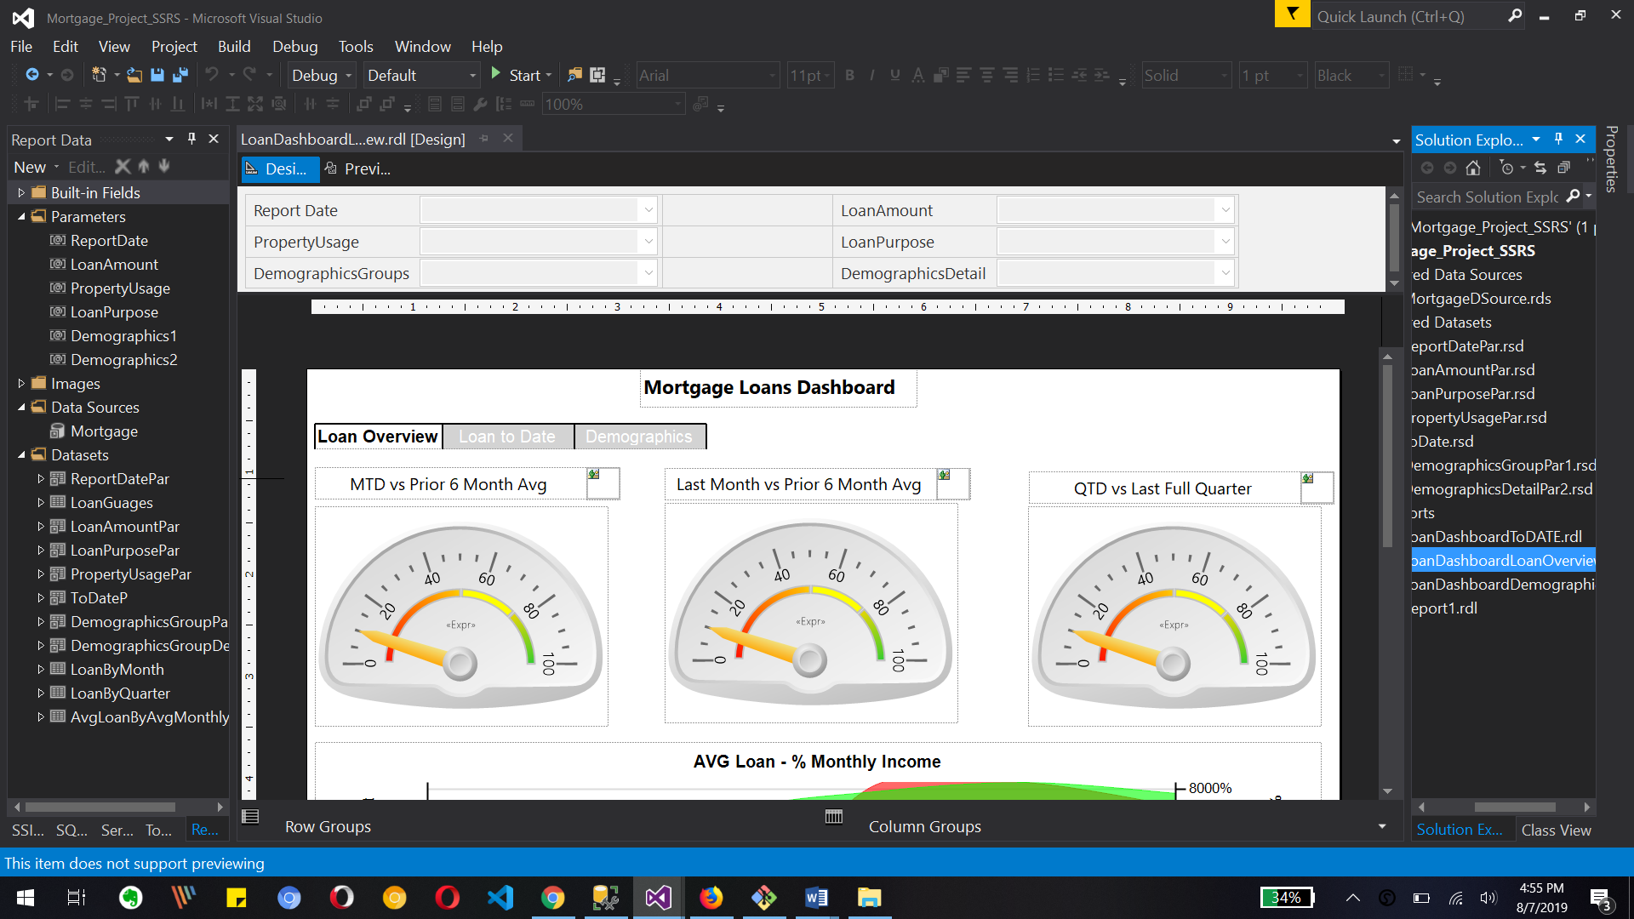

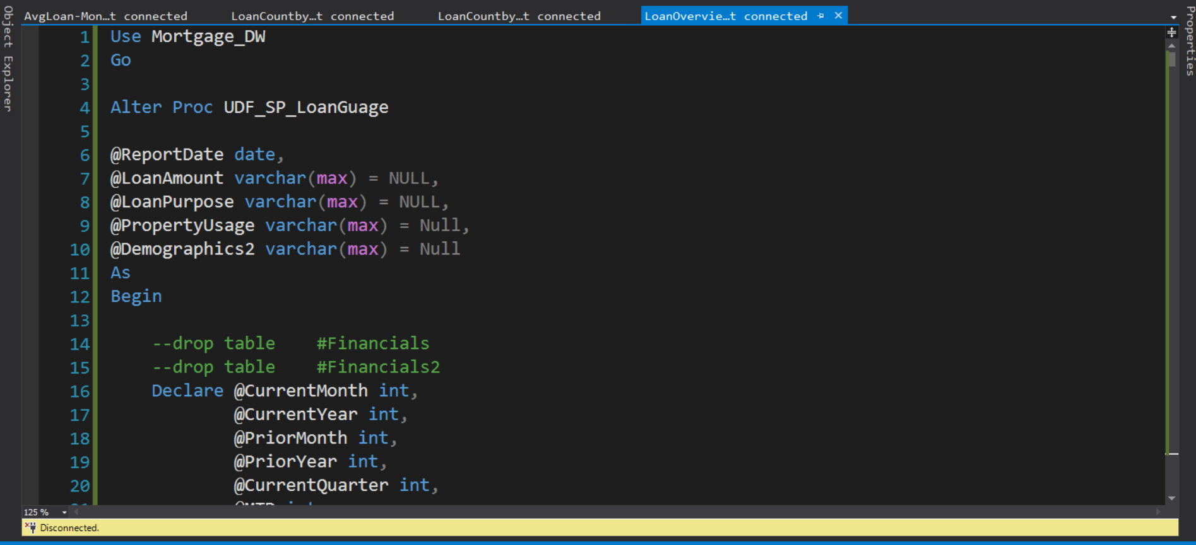

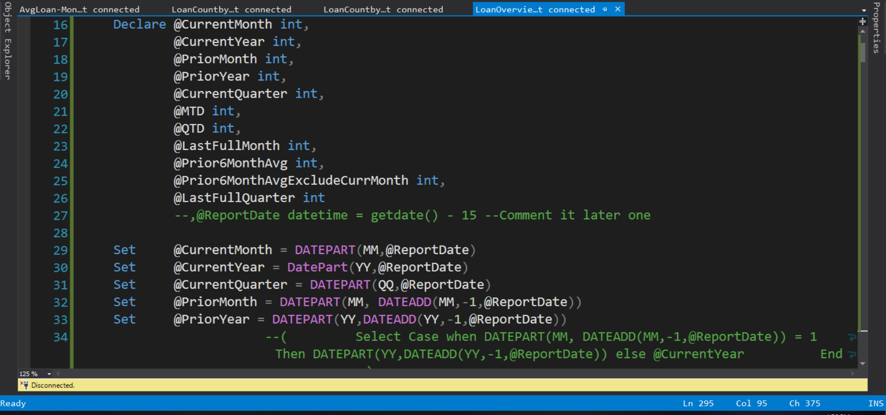

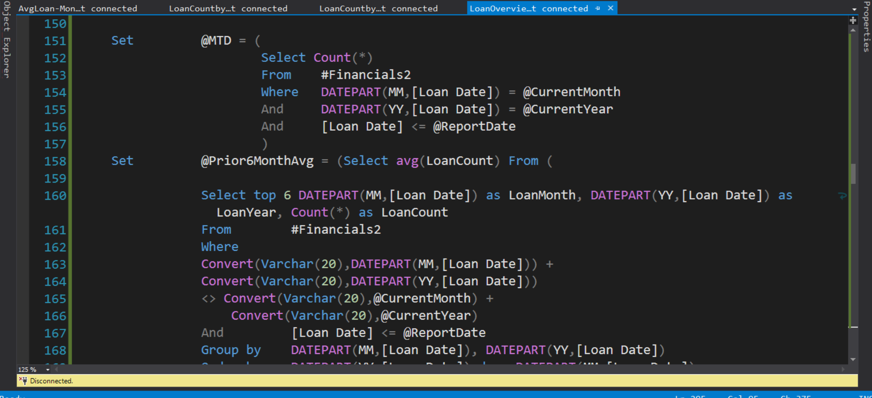

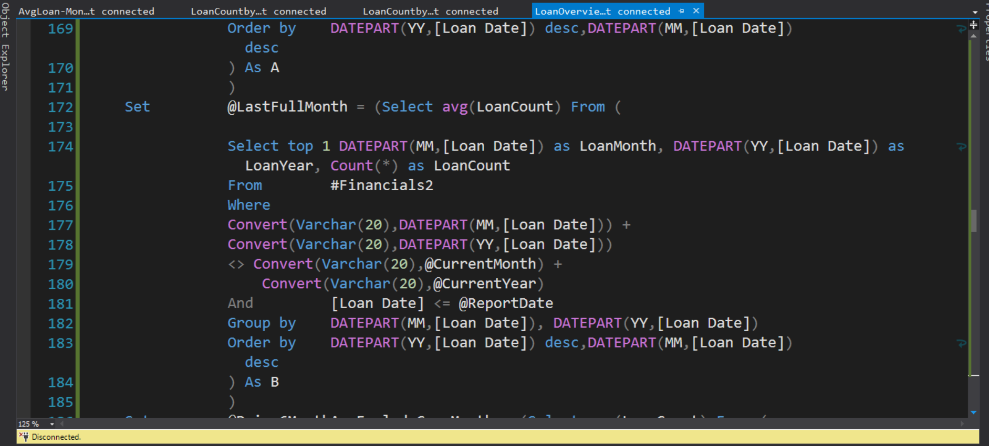

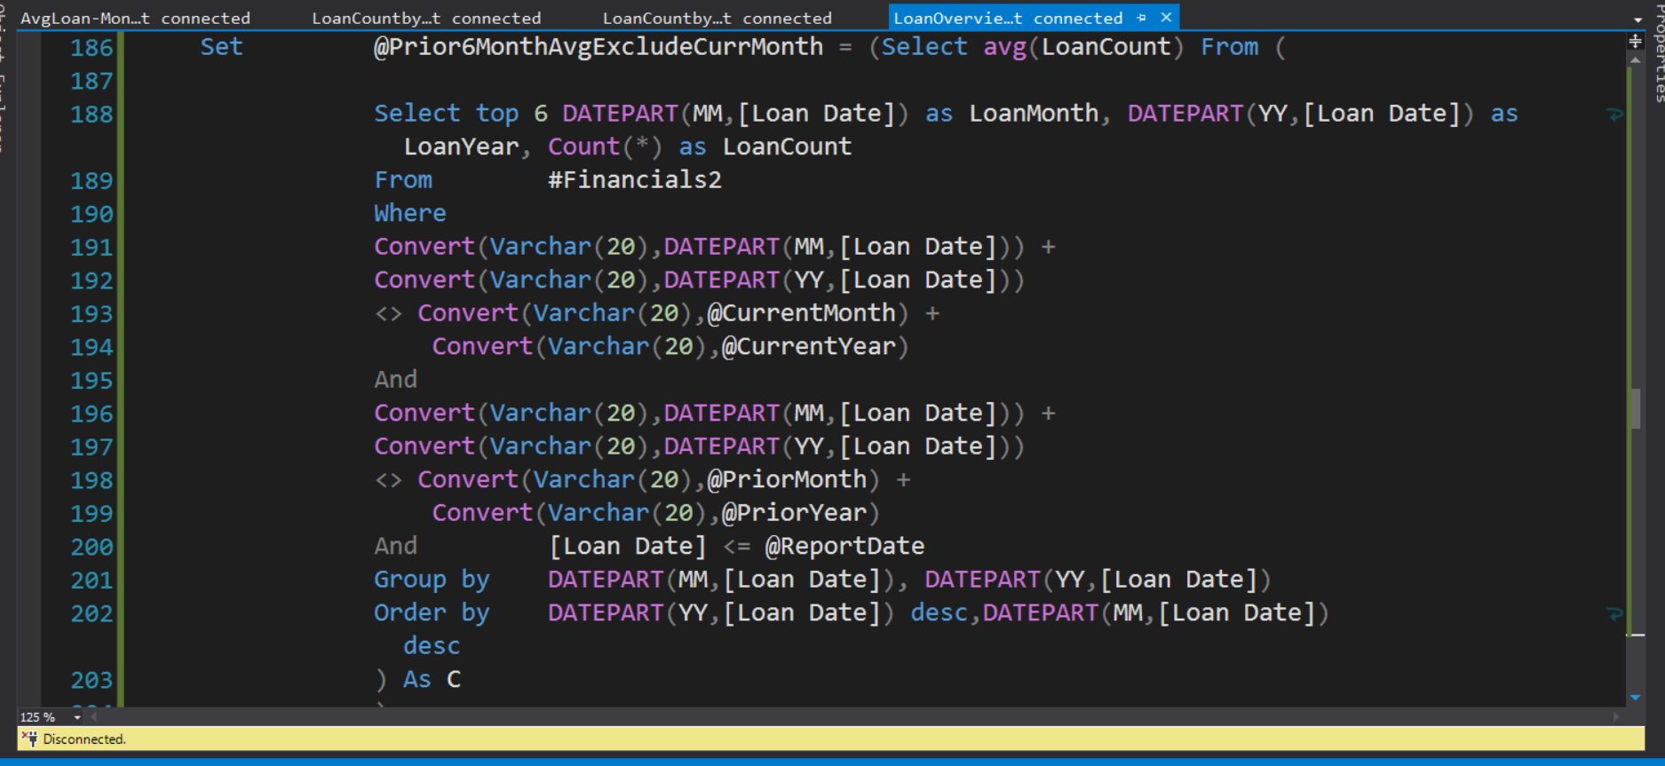

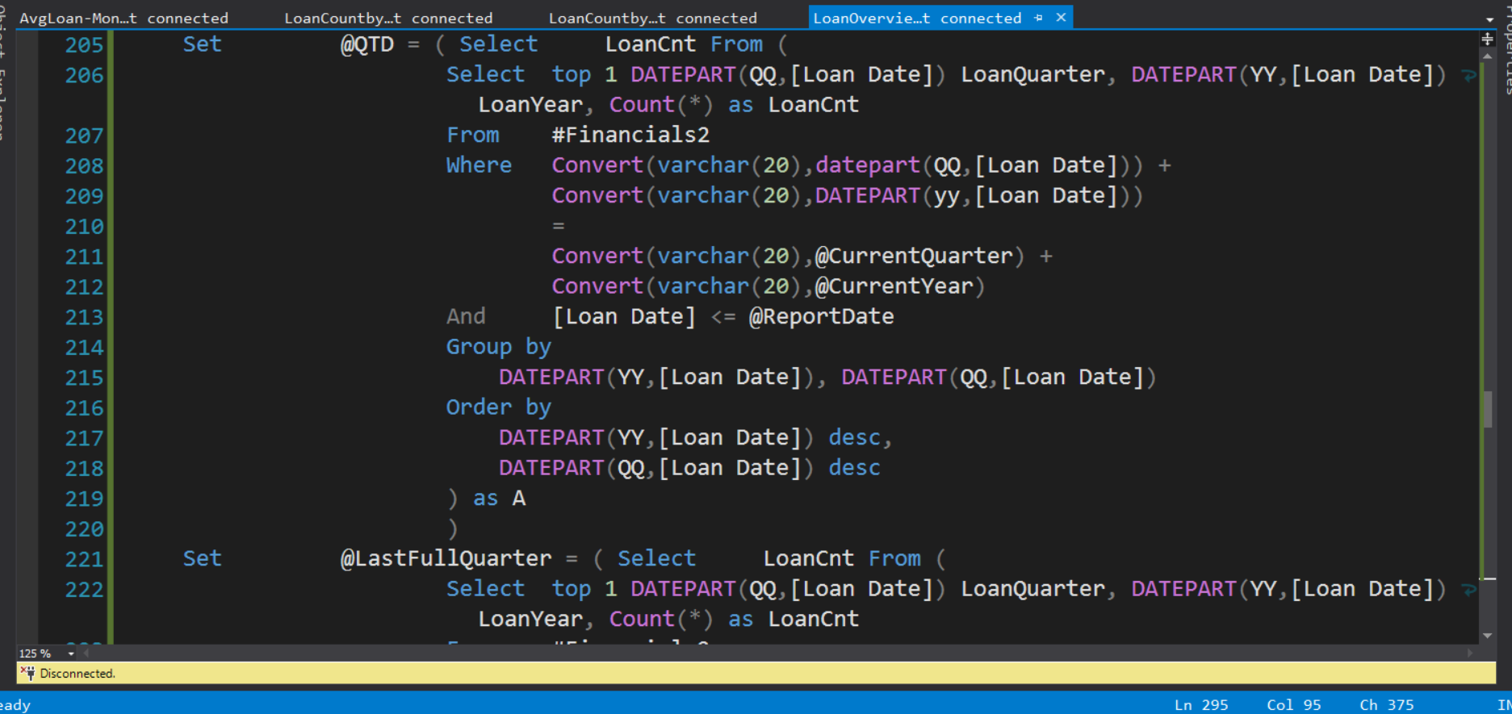

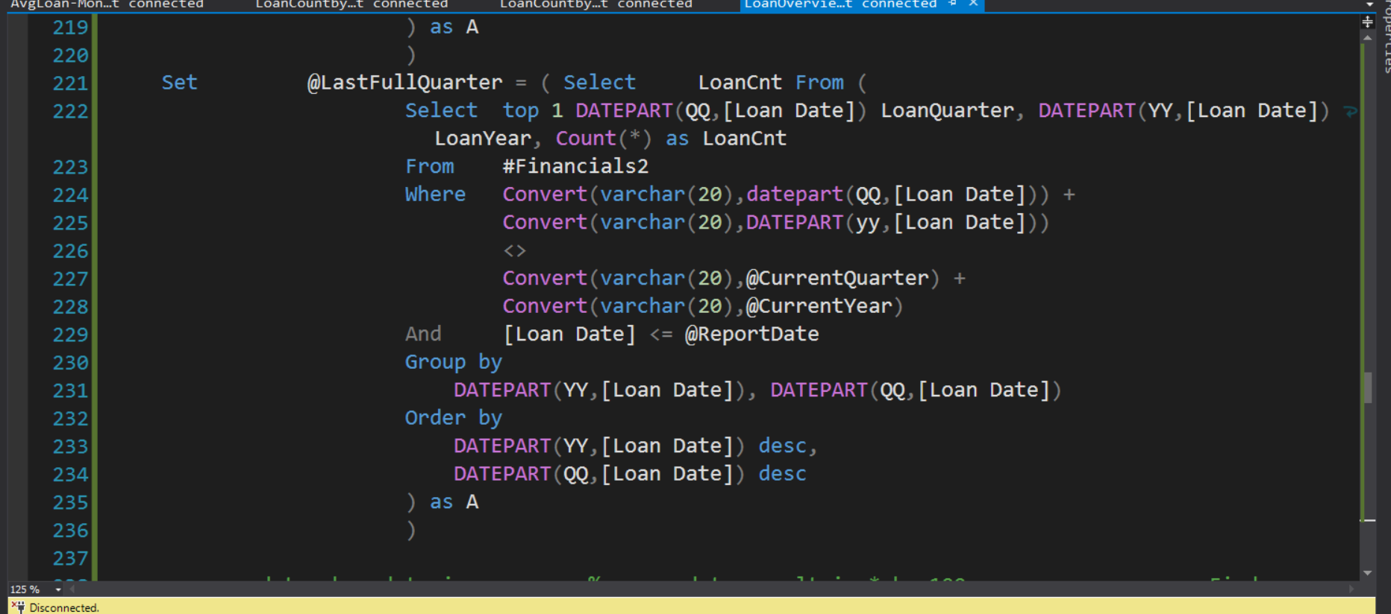

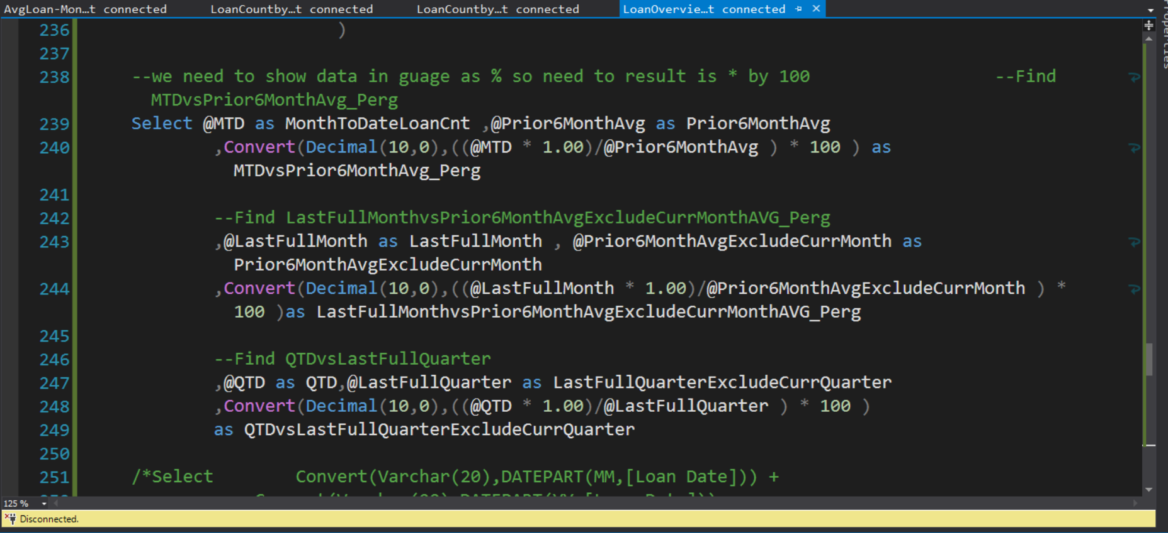

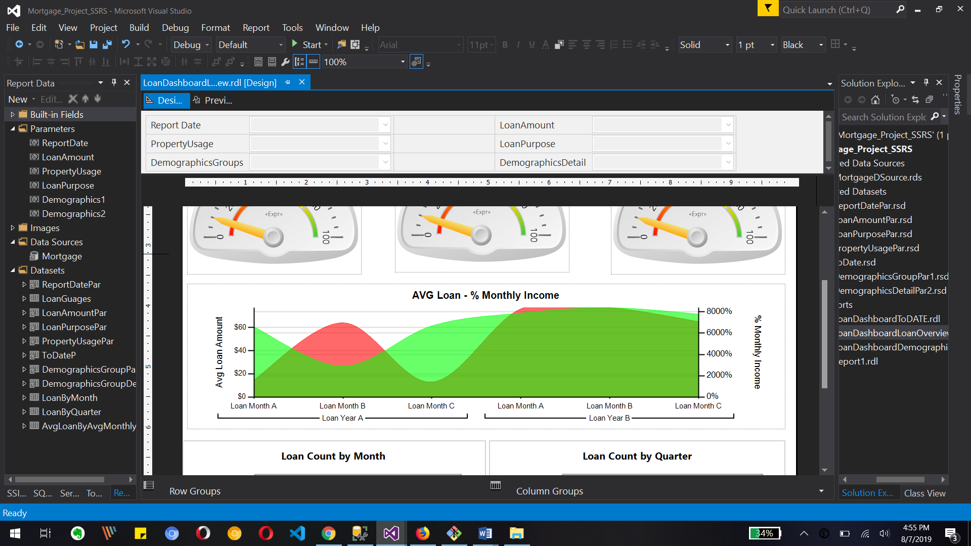

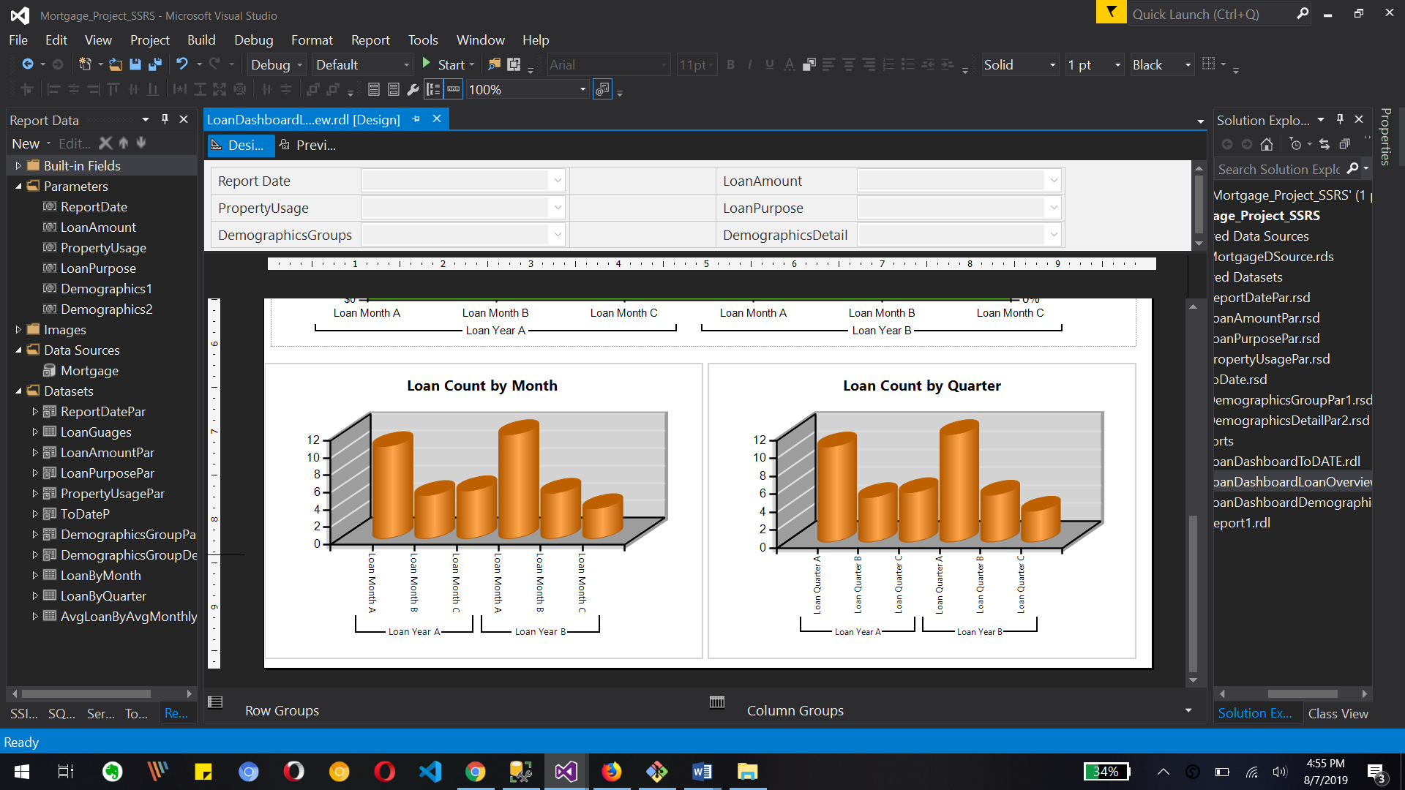

What to Submit:

1. IPBC Status Update : Mortgage Project Story 7 – 9
2. SQL BI Interview Questions: SSRS – What are the various type of reports you have developed

2. Watch, Comment &amp; take screenshots of your comments from 3 other videos on the same

topic (per question). Comments must be 20+ characters. Leave comments based on

presentation, delivery and/or technical details. Your critiques will help you be more

conscious of your own videos. (3 comment screenshots per Video Question)